**The efficiency of therapeutic ultrasound in physical therapy**

Fatma Youniss1, Naser Amein2, Adel El Alwani2, Mahmud Buhaiba3 Fadwa Farag2, Maryam Mohamed2, . Radiology department1, physical therapy department2, College of Medical Technology-Benghazi1.2. Faculty of Medical Technology, Tobruk University3,Assalam International University, physical therapy faculty1,2.

**Abstract:**

Ultrasound, is a form of high-frequency sound waves, has become an essential tool in modern medicine due to its non-invasive, safe, and versatile nature. Its primary use lies in diagnostic imaging, where it enables real-time visualization of internal organs, tissues, and blood flow without the risks associated with ionizing radiation. Ultrasound is widely employed in obstetrics for fetal monitoring, in cardiology for assessing heart function, musculoskeletal and abdominal imaging. Beyond diagnostics, therapeutic ultrasound is used in physical therapy to promote tissue healing, reduce inflammation and alleviate pain. It also has an application in targeted drug delivery and breaking down kidney stones. Recent advancements in ultrasound technology have future expanded its potential in interventional procedures, cancer treatment, and regenerative medicine. Overall, ultrasound continues to be a safe, cost-effective, and rapidly evolving tool in both diagnostic and therapeutic areas of healthcare. This review paper to explain the importance of the usage of ultrasound waves in physical therapy specially the efficacy and its mechanism based on the molecular biology principles toward tissues healing.

**Key words**: ultrasound waves, ultrasound efficiency, therapeutic ultrasound, medical ultrasound, physical therapy.

**Introduction:**

Ultrasound waves are form of energy which consists of mechanical vibrations as waves with frequencies above the range of human hearing above 20 KHz. Most medical applications employ frequency in the range 1 to 3 MHZ for physical therapy purposes [1]. These waves, are similar to the X-radiation in its nature but different in their interactions with water, that it does not cause ionizations or any free radicals' production, which can damage tissues or increase cancer risk. Decades of use in all medical fields show no proven long-term destructive effects on human's tissues when applied correctly [2]. These waves are longitudinal waves composed of particles undergoing vibration backwards and forwards about their mean position.

The ultrasound energy is transferred in the medium in the form of a disturbance in an equilibrium arrangement of the medium without any particle transfer of matter [3]. Theas waves cannot travel through the vacuum because ultrasound energy transfer to the medium particles which they vibrate to provide deep heating to the joint structures including the muscles, tendons, joints and ligaments.

The amount of ultrasound thermal energy has to be monitored to achieve appropriate therapy and prevent tissue damage. The maximum temperature needed in the range between 40-450C for a minimum of 5 minutes. After this period, there is a window of up to 10 minutes in which the tissue remains flexible and can be stretched. These effects cause increased blood flow, reduced muscle spasms, and greater flexibility in collagen fibers [4-6]. Thermal energy of ultrasound waves can be produced from both pulsed or continuous modes of ultrasound instrumentations. Most ultrasound equipment can generate eighter continuous or pulsed ultrasound energy, the maximum intensity from continuous ultrasound is 3 w/cm2, while the pulsed ultrasound can raise to 5 w/cm2.

The efficacy of ultrasound in physical therapy has two categories that are thermal and mechanical effects. This review paper to shed the light on the importance of the ultrasound waves in physical therapy.

**Therapeutic ultrasound Efficacy:**

Therapeutic ultrasound uses high frequency sound waves typically 1-3 MHz to treat soft tissue injuries, muscle pain, and joint inflammation (figure 1). Its common applications are: reduces chronic and acute pain by increasing blood flow decreasing inflammation, enhancing tissue healing, stimulates tissue regeneration in muscles, tendons, and ligaments, reducing muscle spasms and stiffness [7]. Deep heating effects helps relax tight muscles and improve mobility, helps break down adhesions and scar tissue after injury or surgery, ultrasound waves use to deliver topical drugs like anti-inflammatories drugs deeper into the skin. Moreover, these waves are useful to treat some conditions such as; tendonitis, bursitis, muscle strains or sprains, frozen shoulder, plantar fasciitis and joint inflammation. Although, some precautions are important for the appropriate use of ultrasound waves in physical therapy, these are; not used over areas with malignant tumors, infections, pregnant uterus, or implanted devices. In the conclusion, ultrasound waves are useful tool in physical therapy that should only be applied by trained professionals.

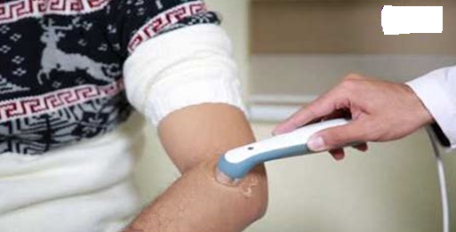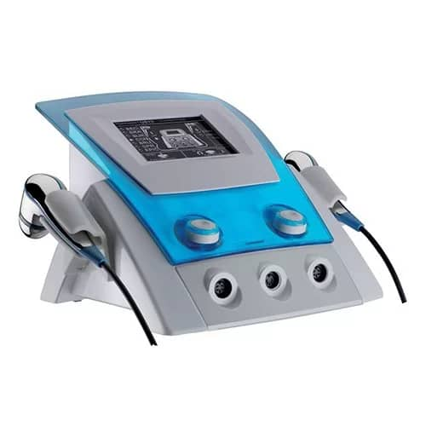

Figure 1 ultrasound equipment and application. The massage should be made with a regular and constant movement of the treatment head. If the head is moved too slowly, unwelcome heat may develop; if, on the other hand, the head is moved too fast a bad contact may result between the head and the skin, thus reducing the efficacy of the therapy.

**Thermal effects of ultrasound waves**:

Thermal effects occur when ultrasound waves cause molecular vibrations in tissues. These vibrations lead to frictions between molecules that generate heat and increase tissue temperature, especially in tissues with high collagen content such as: tendons, ligaments, joint capsules, and scar tissues [8-11]. The physiological effects of ultrasound-induced heating led to increasing tissue temperature, enhanced blood flow which improves nutrient delivery and waste removal. Moreover, ultrasound -induced heating can promote increasing in tissue extensibility that helpful before stretching (figure 2). In addition, reduce muscle spasms, pain relief via reduction of nerve sensitivity, acceleration of healing by improving enzyme activity and cellular metabolism. These thermal effects are used only in continuous mode, not in pulsed mode where they treat the chronic tendonitis, muscle tightness, scar tissue softening and joint contractures. High intensity focused ultrasound (HIFU) used high temperature to destroy tumors [12]. Some safety precautions are important to be considered for decent treatment such as overheating must be avoided can cause burns or tissue damage. Care is needed in areas with poor blood circulation or over implants like pace makers or hearing aids. Pregnant uterus is very sensitive to thermal effects of ultrasound, thus avoiding the usage of ultrasound treatment over these conditions to ensure highly level of curative treatment [13].

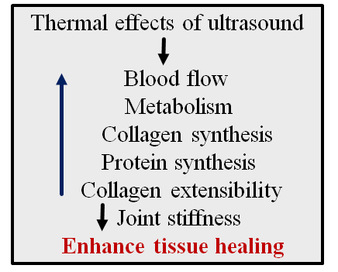

Figure 2 Thermal effects of ultrasound. Increasing blood flow that leads to enhancement of metabolic procedures, collagen and protein synthesis to increase collagen extensibility and reducing joint stiffness to finally accomplishment the tissue healing.

**Mechanical effects of ultrasound waves**:

Mechanical effects of ultrasound also called non-thermal effects of ultrasound which are refer to the biological effects that occur in tissues without a significant rise in temperature. These effects are primarily mechanical in nature and are important in both medical imaging and physical therapy [13-16]. Main non-thermal effects are: cavitation that is formation and activity of small gas-filled bubbles in tissues or fluids due to ultrasound pressure changes. These bubbles include: stable cavitation defined as bubbles oscillate without collapsing can enhance cell membrane permeability [17]. Unstable bubbles, also called transient bubbles are cavitations collapse violently may cause cell damage. Another mechanical effect of therapeutic ultrasound is acoustic streaming defined as steady, circular fluid movement caused by ultrasound waves enhances nutrient transport, waste removal and may stimulate cell activity [18]. Micromassage or mechanical vibrations of ultrasound waves may reduce edema, improve blood flow increasing angiogenesis, chondrogenesis, and osteogenesis thar lead to bone healing enhancement (figure 3). In addition, the propagation of ultrasound waves into tissues cause elevated pressure leading to radiation force can displace particles or cells influencing cell signaling promoting antiapoptotic process and growth factors production. [19-20].

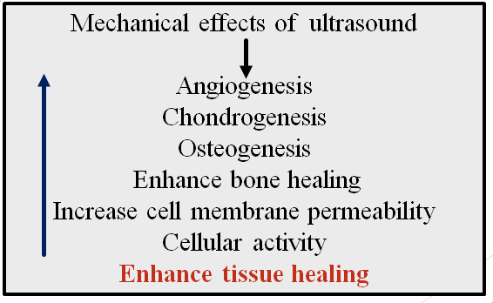

Figure 3 mechanical effects of ultrasound including angiogenesis, chondrogenesis, and osteogenesis to increase cell membrane permeability and enhance tissue healing.

**Ultrasound transducer (probe):**

The transducer probe consists of the piezoelectric disc with electrodes, electrical connections, the housing, and front facing which has two shapes non damping backing to produce continuous US waves and damping backing block to produce pulsed US waves (figure 4). The piezoelectric materials that construct the transducer convert the electrical energy to mechanical energy when the electrical charge is applied to them. The piezoelectric materials that have been used in the US equipment's such as quartz, lithium sulphate or barium titanate [21]. Powerful piezoelectric materials are chosen according to their application and required probe characteristics, less complicated manufacturing and due to acoustic, technical or economic reasons. The housing contains layer of metal to serve as faraday cage to ensure that no external electromagnetic fields induce interference voltage in the crystal or connecting wires. Also, to minimize the emission of electromagnetic radiations from the crystal and connectors.

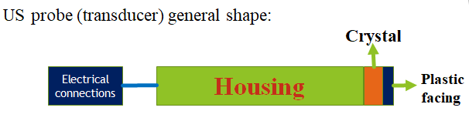

Figure 4 components of ultrasound transducer that produce ultrasound waves. The transducer probe consists of the piezoelectric disc with electrodes, electrical connections, the housing, and front facing.

Transducer probe consists of linear array of small elements, which contact with each other. Each element generates waves which spread uniformly in all direction ultrasound beam propagate into near and far fields [22]. Near field is called Fresnel Zone is the area between the probe and the point at which the beam starts to diverge. Where the beam remains cylindrical along the direction of the beam axis. The far field is called Fraunhoffer Zone is diverging part of the beam.

Dead spots are regions near the probe caused by destructive interference at which there is little or no ultrasonic energy and from which ultrasonic echoes cannot be received. Dead spots do not occur in the far field because destructive interference cannot take in the near filed the ultrasound waves are longitudinal, the attenuation can be neglected and the intensity remains constant along the beam. In the far field the beam becomes spherical and the intensity declines inversely as the square distance [23]. In the. For medical application is desirable to operate close to the near field avoiding the far field. For this reason, high frequency transducer with small crystal radius provides enough near field to extend to tissue depths of interest. If the frequency is lowered the transducer radius must be increased in order to obtain long near field.

**Conclusion:**

In conclusion, the therapeutic effects of ultrasound play a significant role in the treatment of most pathological conditions of all joints. When ultrasound waves absorbed by tissues, they generate both thermal and mechanical effects which increase blood flow, enhance tissue extensibility, and promote healing. These effects are particularly beneficial in physical therapy and rehabilitation. However, it is crucial to control exposure parameters to avoid potential tissue damage due to overheating. Understanding and properly applying the therapeutic ultrasound ensures its safety and effectiveness use in medical practice.

**References:**

1- Yoshida, T.; Yoshida, T.; Noma, H.; Nomura, T.; Suzuki, A.; Mihara, T. Diagnostic accuracy of point-of-care ultrasound forshock: A systematic review and meta-analysis. Crit. Care. 2023, 27, 200.

2-American College of Emergency Physicians. ACEP emergency ultrasound guidelines—2001. Ann Emerg Med. 2001, 38, 470–48.

Chiang J, Cristescu M, Lee MH, et al. Effects of microwave ablation on arterial and3 venous vasculature after treatment of hepatocellular carcinoma. Radiology. 2016;281(2):617– 624.

4-Wang Y-N, Brayman A, Leotta D, et al. Non-invasive treatment of abscesses by histotripsy. J Acoust Soc Am. 2019;146(4):2992–2992.

5-Haar GT, Coussios C. High intensity focused ultrasound: physical principles and devices. Int J Hyperthermia. 2007;23(2):89–104.

6-Parsons JE, Cain CA, Abrams GD, et al. Pulsed cavitational ultrasound therapy for controlled tissue homogenization. Ultrasound Med Biol. 2006;32(1):115–129.

7-Ter Haar GR. High intensity focused ultrasound for the treatment of tumors. Echocardiography 202318(4) 327-322..

8-Crum LA, Fowlkes JB. Acoustic cavitation generated by microsecond pulses of ultrasound Nature. 1986;319(6048):52–54..

9-Fry FJ, Kossoff G, Eggleton RC, et al. Threshold ultrasonic dosages for structural changes in the mammalian brain. J Acoust Soc Am. 1999;48(6):l 2:1413.

10-Delius M, Denk R, Berding C, et al. Biological effects of shock waves: cavitation by shock waves in piglet liver. Ultrasound Med Biol. 1990;16(5):467–472.

11-Arefiev A, Prat F, Chapelon JY, et al. Ultrasound-induced tissue ablation: studies on isolated, perfused porcine liver. Ultrasound Med Biol. 1998;24(7):1033–1043

12-Topaz M, Motiei M, Assia E, et al. Acoustic cavitation in phacoe-mulsification: chemical effects, modes of action and cavitation index. Ultrasound Med Biol. 2002;28(6):775–784.

13-Prat F, Chapelon JY, Abou el Fadil F, et al. Focused liver ablation by cavitation in the rabbit: a potential new method of extracorporeal treatment. Gut. 1994;35(3):395–400.

14-Vlaisavljevich E, Kim Y, Allen S, et al. Image-guided non-invasive ultrasound liver ablation using histotripsy: feasibility study in an in vivo porcine model. Ultrasound Med Biol 2019 (8) 1409-13-1398..

15-Zhang X, Macoskey JJ, Ives K, et al. Non-invasive thrombolysis using microtripsy in a porcine deep vein thrombosis model. Ultrasound Med Biol. 2017;43(7):1378–1390.

16-Bollen V, Hendley SA, Paul JD, et al. In vitro thrombolytic efficacy of single- and five-cycle histotripsy pulses and rt-PA. Ultrasound Med Biol. 2020;46(2):336–349.

17-Bader K, Hendley SA, Bollen V. Assessment of Collaborative Robot (Cobot)-assisted histotripsy for venous clot ablation. IEEE Trans Biomed Eng. 2020.;68(4):1220–1228

18-Khokhlova TD, Monsky WL, Haider YA, et al. Histotripsy liquefaction of large hematomas Ultrasound Med Biol. 2016;42(7):1491–1498. .

19-Villemain O, Robin J, Bel A, et al. Pulsed cavitational ultrasound softening: a new non- invasive therapeutic approach of calcified bioprosthetic valve stenosis. JACC Basic Transl Sci. 2017;2(4):372–383.

20-Pahk KJ, Gelat P, Kim H, et al. Bubble dynamics in boiling histotripsy. Ultrasound Med Biol,2020 (12):44, 2673-2696..

21-Maxwell AD, Cain CA, Hall TL, et al. Probability of cavitation for single ultrasound pulses applied to tissues and tissue-mimicking materials. Ultrasound Med Biol. 2013;39(3):449–465.

22- Maxwell AD, Wang T-Y, Cain CA, et al. Cavitation clouds created by shock scattering from bubbles during histotripsy. J Acoust Soc Am. 2011;130(4):1888–1898.

23- Wang YN, Khokhlova T, Bailey M, et al. Histological and biochemical analysis of mechanical and thermal bioeffects in boiling histotripsy lesions induced by high intensity focused ultrasound. Ultrasound Med Biol. 2013;39(3):424–438.